**CLOUD BASED INDUSTRY MONITORING AND CONTROLLING SYSTEM**

**Done By:**

V. Sandhya Sri

A. Nikitha

O. Jhansi

B. Gayathri

**INTRODUCTION:**

By these project we can detect temperature , gas ,humidity , light. we can reduce harm. System designed to protect industries from losses due to accidents using Internet of things. Gas leakages may lead to fires leading to huge industrial losses. Also low lighting in industries may create improper work conditions increasing the probability of accidents.

**ESP32:**

**ESP32** is a series of low-cost, low-power [system on a chip](https://en.wikipedia.org/wiki/System_on_a_chip) [microcontrollers](https://en.wikipedia.org/wiki/Microcontroller) with integrated [Wi-Fi](https://en.wikipedia.org/wiki/Wi-Fi) and dual-mode [Bluetooth](https://en.wikipedia.org/wiki/Bluetooth).

**Temperature sensor:**

A temperature is a device that detects and measures hotness and coldness and converts it into an electrical signal. If the diffenrence in voltage is amplified the analog signal is generated by the device and it is directly proportional to temperature.it has three terminals and it requires 5.5v power supply.

**Gas sensor:**

A gas sensor is a device which detects the presence of different gases in an area, especially those gases which might be harmful to humans or animals. The developments of gas sensor technology have found wide applications in environmental monitoring, protection, etc.

**LIGHT SENSOR:**

The light sensor is a device which converts light energies of various wavelength some infrarde to Uv into the electrical energy(or to an electrical signal).These is the reason that they are called photo electric devices.

They sense the light during this process so they can be called as photo sensors.

**Humidity sensor:**

A humidity sensor (or hygrometer sensor) measures and report both moisture and air temperature. The ratio of moisture in the air to the highest amount of moister at a particular air temperature is called relative humidity. It work by detecting changes that alter electrical currents or temperature in the air.

**BlockDiagram:**

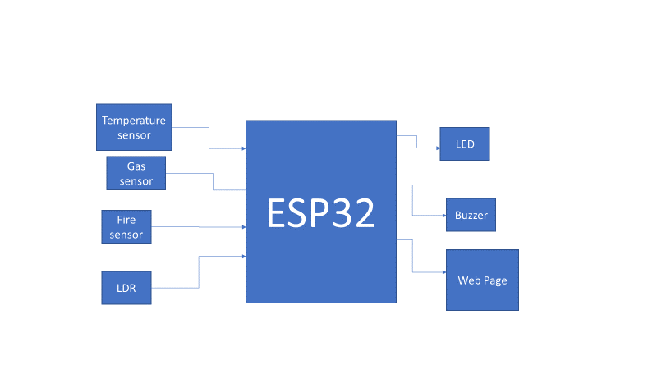

**Results:**

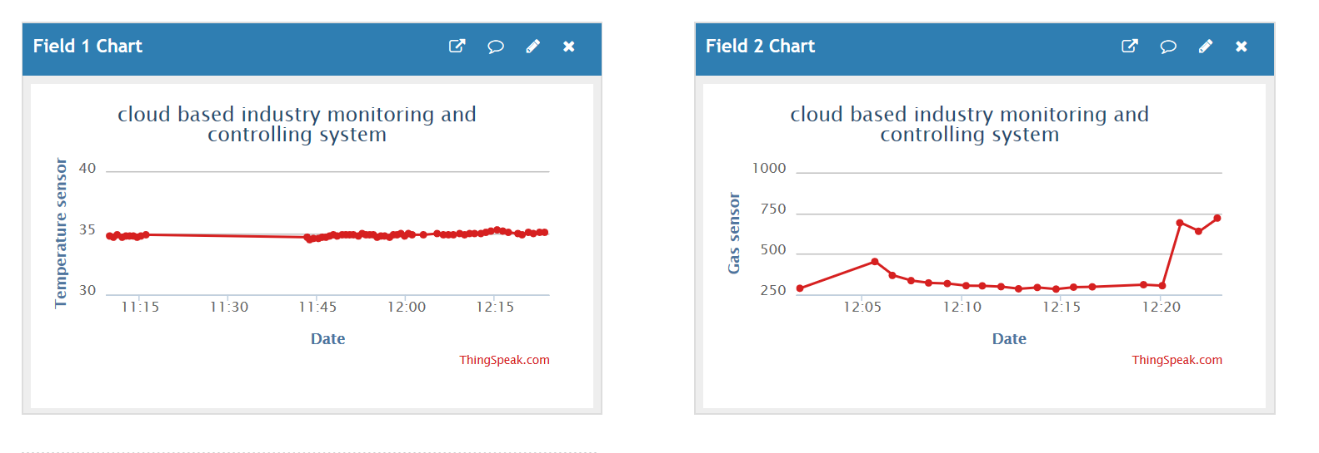

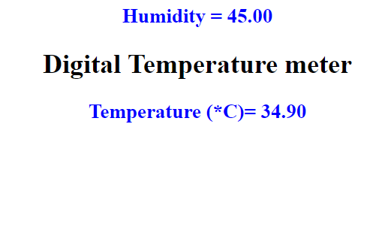

**Advantages:**

Gas leakages may be less without Couse any affects.

When an accident occurs in an industry the buzzer and led will on then we can provide them faster.

The system makes use of temperature sensing along with light and gas sensing to detect fire, gas leakage as well as low lighting to avoid any industrial accidents and prevent losses.

**Conclusion:**

It will detect the temperature, humidity, light and gas .it will sound a buzzer if the value gets increases and if the LDR value increases it makes both buzzer and LED.